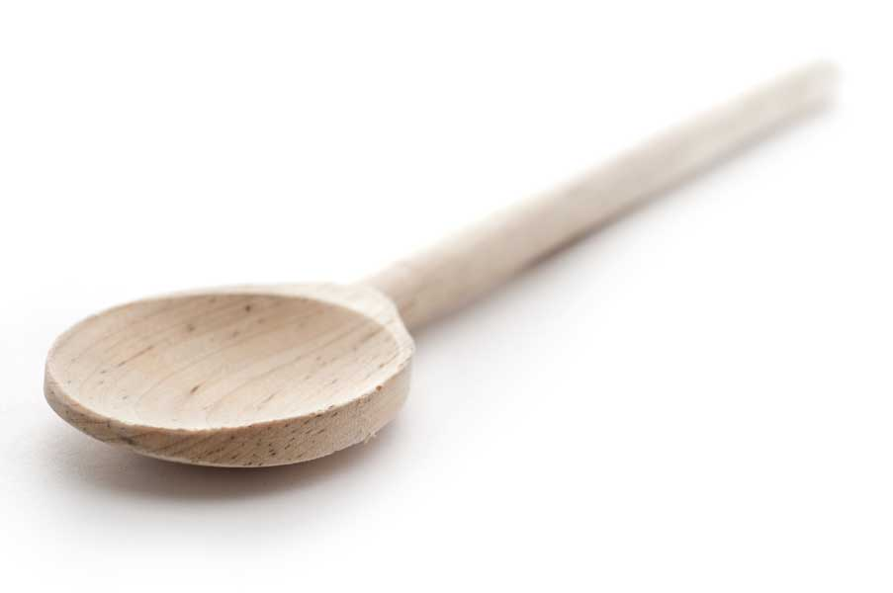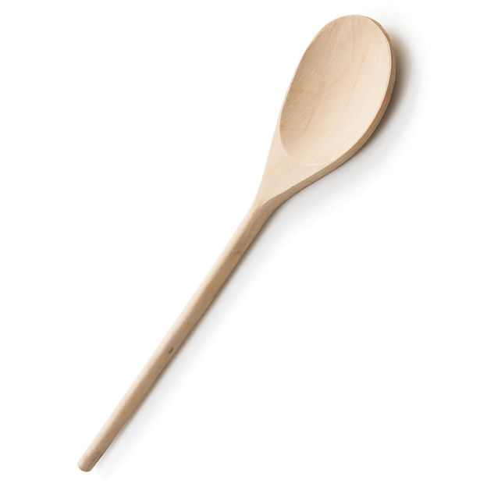

Hazelnut Chocolate Mousse Cake

Ingredients for Chocolate Cake

2 cups flour
2 cups granulated white sugar
3/4 cup unsweetened cocoa powder
1 1/2 tsp. baking soda,
3/4 tsp. salt
2 large eggs
1 cup buttermilk
1/2 cup (1 stick) butter, melted
1 tbl. vanilla extract
1 cup boiling water

Ingredients for Hazelnut Chocolate Mousse Frosting

12 oz. high-quality, bittersweet chocolate (I prefer Ghirardelli)
3 cups heavy whipping cream
1 tbl. hazelnut extract
1 1/3 cups Nutella, or other chocolate hazelnut spread
Directions for Cake
Fit the oven rack in the center of the oven and preheat to 325 degrees. Grease three 8-inch pans (or do as I did if you don’t have three and just use one of them twice) and set aside.

In a medium bowl sift together flour, sugar, cocoa, soda and salt, and set aside.

In the large bowl of a standing mixer, whisk together, by hand, the eggs, buttermilk, and vanilla until combined, and then whisk in the melted butter. With the bowl under the paddle attachment running at a low speed, slowly add the dry ingredients to the wet mixture and continue to beat until smooth, about 2 minute. Remove bowl from mixer and stir in boiling water with a rubber spatula. Batter will be very loose.

Pour the batter evenly between the three 8-inch pans and bake 25 to30 minutes, until a toothpick or fork inserted in the center comes out with just a few steaming crumbs attached.

Allow to cool to room temperature.

Directions for Hazelnut Chocolate Mousse Frosting

In a medium sauce pan, heat chocolate and heavy cream on medium-high heat, whisking constantly until it reaches a boil. Turn down to a low boil and continue whisking for another minute. Remove from heat and pour into a bowl. Quickly stir in the hazelnut extract and Nutella. Let cool completely to room temperature, cover with plastic wrap so that it’s directly touching the frosting, and put in the freezer and leave it in the freezer overnight. It should be very thick, but not unworkable.

To Assemble the Cake

Just before spreading, gently whisk the frosting only until it’s spreadable. (You can use a wooden spoon if the frosting is too thick initially for the whisk.) Frost each of the three layers with even portions of the frosting, heaping it toward the middle of each layer. I didn’t frost the sides, but there is enough frosting to do so if you wish. You can be creative with the topping—for example, top with a pile of raspberries, a pile of mixed berries, cherries with the stems still on, shaved chocolate, chopped nuts, etc.

Yield: One 8-inch, 3-layer cake

www.fransfavs.com

